1. 1.1European Call:

Default:

Let r=1%; S0=50; MP=S0-0.1=49.9; T=1; t0=0; money in bank= 0.1*e^(r*(T-t0))=0.10101;

Assume there is no fee cost to buy options.

1.1 Find a Scenario where this strategy leads to a profit.

Step 1: I buy a call at K=45 at expiration on T=1.

Step 2: Short sell one share of stock, receive cash(C)= S0-0.1=49.9.

I borrow one share of stock. I need to pay one share of stock at T.

Step 3: Saving cash in bank for 49.9.

Step 4:

Thinking Stock price will keep going down.

If Stock Price(St) >= K where K=45, I exercise the call option. St = 48.

At time T, I earn the interesting from bank 0.10101 with my saying 49.9.

Total I have cash 50.00101.

Here, I exercise the call, buy it at price K=45.

Result cash in hand = 50.00101-45=5.00101.

Then, I borrowed one share of stock before, so I pay it with this one share of stock from call. It cancels out.

The profit I earn is 5.00101.

If St<K, St=44.

I will not exercise the call, but I still owe one share of stock. I have cash 50.00101 at time T. I buy from stock market at price St=44. Therefore, I have 6.00101 profit and I do not owe anything now. And The fee is zero.

So, I still make total profit is 6.00101.

1.1 Find a Scenario where this strategy leads to a loss.

Step 1: I buy a call at K=55 at expiration on T=1.

Step 2: Short sell one share of stock, receive cash(C)= S0-0.1=49.9.

I borrow one share of stock. I need to pay one share of stock at T.

Step 3: Saving cash in bank for 49.9.

Step 4:

If St>K >S0, St=52. Stock price goes up and K= 55.

I have cash 50.00101 at time T.

I did not want to exercise the call. But I owe one share of stock. I have to buy it from stock market for 52 to cancel out the short selling one share of stock. Result in cash 50.00101-52 = -1.99899 and I do not owe any now.

In the end, I end with profit -1.99899. Result in loss.

1.2. American Call.

Let r=1%; S0=50; MP=S0-0.1=49.9; T=1; t0=0; money in bank= 0.1*e^(r*(T-t0))=0.10101;

Assume there is no fee cost to buy options.

Find a scenario where this strategy leads to a profit.

Step 1: I buy a call at K=47 at expiration on T=1.

Step 2: Short sell one share of stock, receive cash(C)= S0-0.1=49.9.

I borrow one share of stock. I need to pay one share of stock at T.

Step 3: Saving cash in bank for 49.9.

Step 4:

t0<t1<T, St= 49 at t1, and St=47 at T.

At t1=0.5, money in bank= 0.1*e^(r*(t1-t0))=0.1005.

I have cash 50.0005 at time t1 from bank.

At t1, I exercise the stock at K, pay K=47 to get one share of stock.

Result in cash 3.0005. Then I pay back I owe one share of stock from short selling. Now, I do not have a call and I do not owe any thing.

In the end, I earn the profit with 3.0005.

Find a scenario where this strategy leads to a loss.

Step 1: I buy a call at K=51 at expiration on T=1.

Step 2: Short sell one share of stock, receive cash(C)= S0-0.1=49.9.

I borrow one share of stock. I need to pay one share of stock at T.

Step 3: Saving cash in bank for 49.9.

Step 4:

t0<t1<T, St= 52 at t1, and St=45 at T.

At t1=0.5, money in bank= 0.1*e^(r*(t1-t0))=0.1005.

I have cash 50.0005 at time t1 from the bank.

At t1, I want to exercise the stock at K anyway. I pay K to buy one share of stock, resulting in cash 50.0005-51=-0.9995. Then, I pay back the one share of stock I owed.

In the end, I do not owe anything but I have a profit with -0.9995, resulting a loss.

Because I already exercise the call, and I pay back the one share of stock. The St at T1 is not affecting any profit or loss to me.

In the end, I resulting in a loss of 0.9995.

1.3 European put

Default:

Let r=1%; S0=50; T=1; t0=0; Market Price = 45

Assume there is no fee cost for options.

Find a scenario where this strategy leads to a profit.

Step 1: At t0, I buy put option with cash = PV(K)-0.1=44.9. K=48

Step 2: I have to borrow 44.9 from bank.

Step 3: At T, St = 40.

Step 4: I exercise the put option, selling it at K=48. But I have to buy one share of stock first, cost 40. I have to borrow 40. Total borrowing is 40+ 44.9+0.1*e^(0.001(1-0))=44.501

Step 5: I sell the one share of stock, exercise the put option, receiving 48.

Step 6: I pay back to bank for 44.501

Step 7: I get cash 48-44.501=3.499.

Resulting in a profit.

Find a scenario where this strategy leads to a loss.

Step 1: At t0, I buy put option with cash = PV(K)-0.1=4.4. K=42

Step 2: I have to borrow 4.4 from bank.

Step 3: At T, St = 52.

Step 4: I do not exercise the put option, So, I do not need to buy stock, total borrowing = 4.4+0.1*e^(0.001(1-0))=4.501. I have 4.4, total loss is 0.101.

Step 5: I have to pay back to bank 4.501.

Resulting in a loss with 0.101.

1.4 American put

Default:

Let r=1%; S0=50; T=1; t0=0; Market Price = 4.5

Assume there is no fee cost for options.

Find a scenario where this strategy leads to a profit.

Step 1: At t0, I buy put option with cash = PV(K)-0.1=4.4. K=48

Step 2: I have to borrow 4.4 from bank.

Step 3: At t1=0.5<T, St = 40.

Step 4: I exercise the put option, selling it at K=48. But I have to buy one share of stock first, cost 40. I have to borrow 40. Total borrowing is 40+ 4.4+0.1*e^(0.001(0.5-0))=44.501

Step 5: I sell the one share of stock, exercise the put option, receiving 48.

Step 6: I pay back to bank for 44.501

Step 7: I get cash 48-44.501=3.499. I finish the trading, so, i do not care St at T.

Resulting in a profit.

Find a scenario where this strategy leads to a loss.

Step 1: At t0, I buy put option with cash = PV(K)-0.1=4.4. K=42

Step 2: I have to borrow 4.4 from bank.

Step 3: At t1=0.5<T, St = 52. And St is keep at 52 or greater than 52 until time T.

Step 4: I do not exercise the put option, So, I do not need to buy stock, total borrowing = 4.4+0.1*e^(0.001(1-0))=4.501

Step 5: I have to pay back to bank 4.501.

Step 6: Even though I decide to not exercise the put option, I still need to pay some interest to bank with money I borrowed. However, I earn nothing. It still a loss.

Resulting in a loss.

2. S0=100.0, t0=0, F0=103.25, F5=S5.

|  |  |  |  |  |  |  |
| --- | --- | --- | --- | --- | --- | --- |
| i | Si | Fi | dividend | Money received | Money Paid | Net Profit |
| 0 | 100 | 103.25 |  |  |  |  |
| 1 | 100.75 | 104.25 |  |  |  |  |
| 2 | 100.23 | 102.67 |  |  |  |  |
| 3 | 99.95 | 100.23 | 0.1 |  |  |  |
| 4 | 99.51 | 99.23 |  |  |  |  |
| 5 | 99 | 99 |  |  |  |  |

2.1 Investor A

Investor A goes long one share of stock on day 0, sells the stock on day 5.

|  |  |  |  |  |  |  |
| --- | --- | --- | --- | --- | --- | --- |
| i | Si | Fi | dividend | Money received | Money Paid | Net Profit |
| 0 | 100 | 103.25 |  | 0 | 100 | -100 |
| 1 | 100.75 | 104.25 |  | 0 | 0 | -100 |
| 2 | 100.23 | 102.67 |  | 0 | 0 | -100 |
| 3 | 99.95 | 100.23 | 0.1 | 0.1 | 0 | -99.9 |
| 4 | 99.51 | 99.23 |  | 0 | 0 | -99.9 |
| 5 | 99 | 99 |  | 99 | 0 | -0.9 |

The investor A is earning on day 3, he receives dividend 0.1. And he makes loss 0.9 on day 5.

2.2 Investor B

B goes long one futures contract on day 0, hold the future contract to expiration.

|  |  |  |  |  |  |  |
| --- | --- | --- | --- | --- | --- | --- |
| i | Si | Fi | dividend | Money received | Money Paid | Net Profit |
| 0 | 100 | 103.25 |  | 0 | 0 |  |
| 1 | 100.75 | 104.25 |  | 1 | 0 |  |
| 2 | 100.23 | 102.67 |  | 0 | 1.58 |  |
| 3 | 99.95 | 100.23 | 0.1 | 0 | 2.44 |  |
| 4 | 99.51 | 99.23 |  | 0 | 1 |  |
| 5 | 99 | 99 |  | 0+99 | 0.23+99 |  |
|  |  |  |  | 1 | 5.25 | -4.23 |

Investor B pays 5.25 in the end and receives 1 in the end. Pay F5 to receive one share of stock and sell it immediately, the money cancel out.

2.3 Investor C

C goes long one futures contract on day 0, and sell the futures contract on day 1.

|  |  |  |  |  |  |  |
| --- | --- | --- | --- | --- | --- | --- |
| i | Si | Fi | dividend | Money received | Money Paid | Net Profit |
| 0 | 100 | 103.25 |  | 0 | 0 | 0 |
| 1 | 100.75 | 104.25 |  | 1+100.75 | 104.25 | -3.5 |
| 2 | 100.23 | 102.67 |  | 0 | 0 | 0 |
| 3 | 99.95 | 100.23 | 0.1 | 0 | 0 | 0 |
| 4 | 99.51 | 99.23 |  | 0 | 0 | 0 |
| 5 | 99 | 99 |  | 0 | 0 | 0 |
|  |  |  |  | 101.75 | 104.25 | -3.5 |

On day 1, C makes a lose. He sells the future contract, pay with F1 which is 104.25. Then, he sells it to market with S1, he received total 101.75. His net profit is loss 3.5 on day 1. After it, he finishes his trading, there is no gain or loss after day 1.

2.4 Investor D

D goes long a forward contract on day 0, with F(fwd)=103.25 with expiration day, 5 days.

|  |  |  |  |  |  |  |
| --- | --- | --- | --- | --- | --- | --- |
| i | Si | Fi | dividend | Money received | Money Paid | Net Profit |
| 0 | 100 | 103.25 |  | 0 | 0 | 0 |
| 1 | 100.75 | 104.25 |  | 100.75*3 | 0 | 100.75*3 |
| 2 | 100.23 | 102.67 |  | 0 | 0 | 100.75*3 |
| 3 | 99.95 | 100.23 | 0.1 | 100.85*3 | 0 | 100.85*3 |
| 4 | 99.51 | 99.23 |  | 0 | 0 | 100.85*3 |
| 5 | 99 | 99 |  | 0 | 103.25+99*2 | 1.3 |

On day 1, short selling a stock at stock price 100.75, receive 100.75.

On day 3, D received the dividend 0.1, total received 100.85.

On day 5, D buys a stock at 99, get profit 1.85. D pay forward contract at price 103.25.

To lock in a guaranteed profit, D have to do below things.

If D buys 3 share of stock on day 1, receive 3*0.1 in day 3, D will received 302.55 at day 5. In day 5, buy 2 share of stock with cash 2*99+103.25=301.25. Resulting in total profit 1.3.

On day 1, D receives profit of 100.75*3.

On day 3, D receives profit of 0.1*3.

On day 5, D receives profit of 1.3 after closing his account.

3.

S0=100, r=5%, current value of index is 1000 points, dividend yield is 1.5%, T=1, t0=0.

3.1 A portfolio consists of: (a) long one European call,

(b) short one European put,

(c) short one forward contract.

Both the call and the put have the same strike price of 105.

The forward price also equals 105.

The portfolio trades at a price of 1.

Answer:

I will take short position.

If I take long position, I buy the portfolio. I pay $1, borrow it from you, and I receive long one European call, short one European put, and short one forward contract. Therefore, I will cost $1, at t0. With interest rate, I owe you 1.05 at time T.

At the time, T, Stock Price is St. For long one European call, I will need to borrow 105 from your to finish this call. For short one European put, I will need one share of stock, and sell it to you for 105. For short one forward contract, I need to borrow money from you to buy this share of stock for 105. Now, I owe your 105+1.05=$106.05. If St>106.05, i make the profit, otherwise, I lose money.

If I take short position, I sell the portfolio, i received $1. I have short one European call, long one European put, long one forward contract. I saving $1 to you, and I will have 1+1(0.05)=$1.05 at time, T.

For short one European call, I received 105 but owe one share of stock.

For long one European put, I buy one share of stock at 105.

For long one forward contract, I pay 105 to get one share of stock.

Short one European call and long one European put cancel out. I only need to borrow 105 from you. But I have 1.05. So, the total loan I borrow from you is 103.95. If Stock price at T is >103.95, I make the profit, otherwise, I lose money.

Therefore, I take short position. I sell the portfolio because I only need stock price greater than 103.95 to make the profit, instead of 106.05. Also, I lose less if stock price lower than 103.95, compare to 106.05.

3.2 A portfolio consists of: (a) long one European call, (b) short one European put, (c) short one forward contract. Both the call and the put have the same strike price of K = 96. The forward price is K − 1 = 95.

3.2.1

The portfolio trades at a price of 1.

Answer:

I choose short position.

If I take long position, I buy the portfolio. I pay $1, borrow it from you ,and I receive long one European call, short one European put, and short one forward contract. Therefore, I will cost $1, at t0. With interest rate, I owe you 1.05 at time T.

At time, T, Stock Price is St. For long one European call, I will need to borrow 96 from your to finish this call. For short one European put, I will need one share of stock, and selling it to you for 96. For short one forward contract, I need to borrow money from you to buy this share of stock for 96. Now, I have one share of stock, and I owe your 95+1.05=$96.05. If St>96.05, i make profit, otherwise, I lose money.

If I take short position, I sell the portfolio, i received $1. I have short one European call, long one European put, long one forward contract. I saving $1 to you, and I will have 1+1(0.05)=$1.05 at time, T.

For short one European call, I received 96 but owe one share of stock.

For long one European put, I buy one share of stock at 96.

For long one forward contract, I pay 95 to get one share of stock.

Short one European call and long one European put cancel out. I only need to borrow 95 from you. But I have 1.05. So, the total loan I borrow from you is 93.95. If Stock price at T is >93.95, I make profit, otherwise, I lose money.

Therefore, I take short position. I sell the portfolio because I only need stock price greater than 93.95 to make profit, instead of 96.05. Also, I lose less if stock price lower than 93.95, comparing to 96.05.

3.2.2

The portfolio trades at a price of 0.9.

Answer:

I choose short position.

If I take long position, I buy the portfolio. I pay $0.9, borrow it from you ,and I receive long one European call, short one European put, and short one forward contract. Therefore, I will cost $0.9, at t0. With interest rate, I owe you 0.9*(1+0.05)=0.945 at time T.

At time, T, Stock Price is St. For long one European call, I will need to borrow 96 from your to finish this call. For short one European put, I will need one share of stock, and selling it to you for 96. For short one forward contract, I need to borrow money from you to buy this share of stock for 96. Now, I have one share of stock, and I owe your 95+0.945=$95.9455. If St>95.945, i make the profit, otherwise, I lose money.

If I take short position, I sell the portfolio, i received $0.9. I have short one European call, long one European put, long one forward contract. I saving $0.9 to you, and I will have 0.945 at time, T.

For short one European call, I received 96 but owe one share of stock.

For long one European put, I buy one share of stock at 96.

For long one forward contract, I pay 95 to get one share of stock.

Short one European call and long one European put cancel out. I only need to borrow 95 from you. But I have 0.945. So, the total loan I borrow from you is 94.055. If Stock price at T is >94.055, I make the profit, otherwise, I lose money.

Therefore, I take short position. I sell the portfolio because I only need stock price greater than 94.055 to make the profit, instead of 95.945. Also, I lose less if stock price lower than 94.055, comparing to 95.945.

3.2.3

The portfolio trades at a price of 1.1.

Answer:

I choose short position.

If I take long position, I buy the portfolio. I pay $1.1, borrow it from you ,and I receive long one European call, short one European put, and short one forward contract. Therefore, I will cost $1.1, at t0. With interest rate, I owe you 1.155 at time T.

At time, T, Stock Price is St. For long one European call, I will need to borrow 96 from your to finish this call. For short one European put, I will need one share of stock, and selling it to you for 96. For short one forward contract, I need to borrow money from you to buy this share of stock for 96. Now, I have one share of stock, and I owe your 95+1.155=$96.155. If St>96.155, i make profit, otherwise, I lose money.

If I take short position, I sell the portfolio, i received $1.1. I have short one European call, long one European put, long one forward contract. I saving $1.1 to you, and I will have 1.1+1(0.05)=$1.155 at time, T.

For short one European call, I received 96 but owe one share of stock.

For long one European put, I buy one share of stock at 96.

For long one forward contract, I pay 95 to get one share of stock.

Short one European call and long one European put cancel out. I only need to borrow 95 from you. But I have 1.155. So, the total loan I borrow from you is 93.845. If Stock price at T is >93.845, I make profit, otherwise, I lose money.

Therefore, I take short position. I sell the portfolio because I only need stock price greater than 93.845 to make profit, instead of 96.155. Also, I lose less if stock price lower than 93.845, comparing to 96.155.

3.3.1

A portfolio consists of: (a) long one European call with strike 99,

(b) long one European put with strike 101.

The portfolio trades at a price of 1.

Answer:

I pick long position.

If I take long position, I buy the portfolio. I pay $1, borrow it from you ,and I receive long one European call with strike 99, and long one European put with strike 101. Therefore, I will cost $1, at t0. With interest rate, I owe you 1.05 at time T.

At time, T, Stock Price is St. For long one European call with strike 99, I will need to borrow 99 from your to finish this call, and receive one share of stock. For long one European put with strike 101, i will received 101 but lose one share of stock.

Now, I borrow 99 from you first, exercise the call, receive one share of strike. Then, I exercise the put, sell this one share of stock and receiving 101. I pay back 99 and 1.05, I end up with $0.95 profit.

If I take short position, I sell the portfolio, i received $1. I have short one European call with strike 99, and short one European put with strike 101. I saving $1 to you at t0, and I will have 1+1(0.05)=$1.05 at time, T.

For short one European call with strike 99, I will need to borrow 99 from your to finish this call, and receive one share of stock.

For short one European put with strike 101, i will received 101 but lose one share of stock.

I will do short one European put with strike 101, I need to buy one share of stock. Then, I short one European call with 99. I pay 99 and I get one share of stock.

In the end, i may have $2+1.05 profit, but there is a problem. Being short, I am the writer, not holder. I have no right but obligation. If the stock price is too high or low, holder may not exercise the option. If some put option is exercise on low stock price, i lose money. If call option is exercise at high stock price, i also lose money.

For the long position, I have right to decide whatever I exercise or not, but I guarantee a profit 0.95 when on the long position. But there is more risk on short position.

3.3.2

A portfolio consists of: (a) long one American call with strike 99,

(b) long one American put with strike 101.

• The portfolio trades at a price of 1.

Answer:

I choose long position.

As what I write in 3.3.1. But I can exercise the option anytime before the expiration time.

In long position, I am the holder, I can decide to when to exercise the option. In order to make maximum profit, I will pick right stock price to exercise it, earn more profit, but guaranteed a minimum profit 0.95 if I do not exercise it until the expiration time , T.

In short position, I am the writer. If stock price changes, and you see the profit and exercise the option, I lose more money. The risk is higher than the situation on 3.3.1 with short position.

Therefore, I choose long position.

3.3.3

A portfolio consists of: (a) long one American call with strike 99,

(b) long one American put with strike 101.

• The portfolio trades at a price of 1.99

Answer:

I pick short position.

If I take long position, I buy the portfolio. I pay $1.99, borrow it from you ,and I receive long one European call with strike 99, and long one European put with strike 101. Therefore, I will cost $1.99, at t0. With interest rate, I owe you 2.0895 at time T.

At time, T, Stock Price is St. For long one European call with strike 99, I will need to borrow 99 from your to finish this call, and receive one share of stock. For long one European put with strike 101, i will received 101 but lose one share of stock.

Now, I borrow 99 from you first, exercise the call, receive one share of strike. Then, I exercise the put, sell this one share of stock and receiving 101. I pay back 99 and 2.0895, I end up with -$0.0895 profit.

If I take short position, I sell the portfolio, i received $1.99. I have short one European call with strike 99, and short one European put with strike 101. I saving $1 to you at t0, and I will have 2.0895 at time, T.

For short one European call with strike 99, I will need to borrow 99 from your to finish this call, and receive one share of stock.

For short one European put with strike 101, i will received 101 but lose one share of stock.

If both call and put exercise at T, i earn 2+2.0895 profit.

But this is the american put and american call. The option may exercise anything less than T. I lose money in both position, but I have chance to earn profit on short, expecting the option is exercise on T.

Therefore, I pick short position.

3.4 • A stock index has a current value of 1000 index points.

• The interest rate is 5% and the index has a dividend yield of 1.5%.

• The volatility of the index is 30%.

--------------------------------------------------------------------------------------------------------------------------------

Volatility of the index is 30%==> sigma=0.3

-sigma*(T-t0) <= ln(S1/S0) <= sigma*(T-t0)

-0.3 <= ln(S1/100) <= 0.3

0.7308182206817179 <=S1/100 <= 1.349858807576003

73.08 <= S1<= 134.99

The stock price, S1 at T will in the range [73.08, 134.99]

Index has a dividend yield of 1.5%

Dividend yield = Annual Dividends Per Share / Price Per Share

0.015 = x / 1

x= 0.015

The stock owner will get 0.015 per share from stock per year.

3.4.1 An American call option on the stock index has a strike of 900 and expiration of 1 year.

The option is cash settled with a multiplier of $1 for every index point that the option is in the money.

=========================================================================

Answer:

I pick long position.

At t0, the stock has a current value of 1000 index points.

Volatility of the index is 30%==> sigma=0.3

-sigma*(T-t0) <= ln(S1/S0) <= sigma*(T-t0)

-0.3 <= ln(S1/1000) <= 0.3

0.7308182206817179 <=S1/1000 <= 1.349858807576003

730.82 <= S1<= 1349.96

The stock price, S1 at T will in the range [730.82, 1349.96].

If I pick long position. Long an American call option on the stock index has a strike of 900. I am expecting the stock index value will go up after one year. On expiration day, I buy stock from you, pay you $900. So, i have to borrow $900 from you. However, I have to pay your $75 first at t0 to buy the call. I also need to borrow $75 at beginning. At t1, the $75 will increase to 78.75. Total borrow is 978.75.

At time T, i get dividend from stock.

Index has a dividend yield of 1.5%. I will get 1.5% *( current stock index value).

If current stock index value is 900, i will get 13.5.

If current stock index value is 1000, i will get 15.

If current stock index value is 1100, i will get 16.5.

Worst scenario is the current stock index value go down to 730.82. I will not exercise it. Hence, it only cost me 78.75 when buying this option with interest rate after 1 year.

However, all above is European call optioN. American call option will allow me to exercise it anytime before the expiration day. It is great opportunity for me to exercise the call option. Buy it as 900 but St is high enough to cover my $75 to $78.75 cost. And there is a guaranteed profit. I can exercise it right away at t0, it only cost 900 for me to exercise it. Total borrow from you is 975 at t0. I sell it right away to market, earn $25 because 1000-975=25. Then, I save 25 to you, and i will get $26.25 at T. This is the guaranteed profit when I do it in t0. During to to T, I may able to earn more profit if the stock index value is increase.

If I pick short position. Short an American call option on the stock index has a strike of 900. I sell it at t0, get $75. Then, I will have 78.75 at T. But I may lose more when stock index value increase. I have to borrow X from you to buy it from market. If it is greater than 978.75, I loss money. And I am writer, I do not have right to choose I exercise it or not. It is more risk for me to getting loss.

3.4.2 • An American put option on the stock index has a strike of 1050 and expiration of 1 year.

• The option is cash settled with a multiplier of $1 for every index point that the option is in the money.

• The option is currently trading at a value of 35 index points.

=========================================================================

Answer:

I will pick long position.

If I pick long position, I am holder, I can exercise it at t0, cost me 1000 to buy from market and sell it to you 1050. And get 50 profit. To do this, I need to pay you 35 dollar, total earn is $15, and it will increase to 15.75. This is my minimum profit if I trade on this way. With American put option, i can exercise it anytime to make more profit before T. At time T, the stock index value have to be 1050+15.75=1065.75 to make me loss. The prediction for the stock index value at T is between [730.82, 1349.96] (calculated from 3.4.1). Hence, I have have up to 55% chance to earn the profit. I will take this long position.

If I pick short position. I earn $35, and it will increase to $36.75. However. If the stock index value is high enough during t0 to T, I am writer, and you may exercise it right away, resulting loss on me. The risk is too high for me. Easy to loss on this position.

4. • A butterfly spread consists of three options on the same stock.

• All three options have the same expiration time T.

• The options have strike prices K1, K2 and K3, which are are equally spaced.

• Hence K2 is located at the midpoint of K1 and K3, so K2 = (K1 + K3)/2.

• A butterfly spread can be created using three call options or three put options.

• The spread consists of long one option at K1, short two options at K2, long one option at K3.

=========================================================================

4.1 European option butterfly spreads

Answer:

Formula: c-p = S - K*e-r(T-t)

For K1, c1-p1 = S - K1* e-r(T-t).

// p1 = -S + K1* e-r(T-t)+c1

For K2, c2-p2 = S - K2* e-r(T-t).

For K3, c3-p3 = S - K3* e-r(T-t).

To prove c1-2c2+c3 = p1-2p2+p3:

Left side = (S - K1* e-r(T-t)+p1) - 2*(S - K2* e-r(T-t)+p2)+(S - K3* e-r(T-t)+p3)

= (S - K1* e-r(T-t) +p1)- 2*(S - ((K1+K3)/2)* e-r(T-t)+p2)+(S - K3* e-r(T-t)+p3)

= S - K1* e-r(T-t) - 2*S+ K1* e-r(T-t) +K3* e-r(T-t)+S - K3* e-r(T-t)+p1-2p2+p3

= p1-2p2+p3

Right side = p1-2p2+p3

= (-S + K1* e-r(T-t)+c1) -2*( -S + K2* e-r(T-t)+c2) +(-S + K3* e-r(T-t)+c3)

= (-S + K1* e-r(T-t)+c1) -2*( -S + ((K1+K3)/2)* e-r(T-t)+c2) +(-S + K3* e-r(T-t)+c3)

= (-S + K1* e-r(T-t)+c1) +2S - K1* e-r(T-t)-2c2 - K3* e-r(T-t)+c3

=c1-2c2+c3

Hence, left side = right side. I proved that the values of a European call butterfly spread and a European put butterfly spread are equal.

4.2

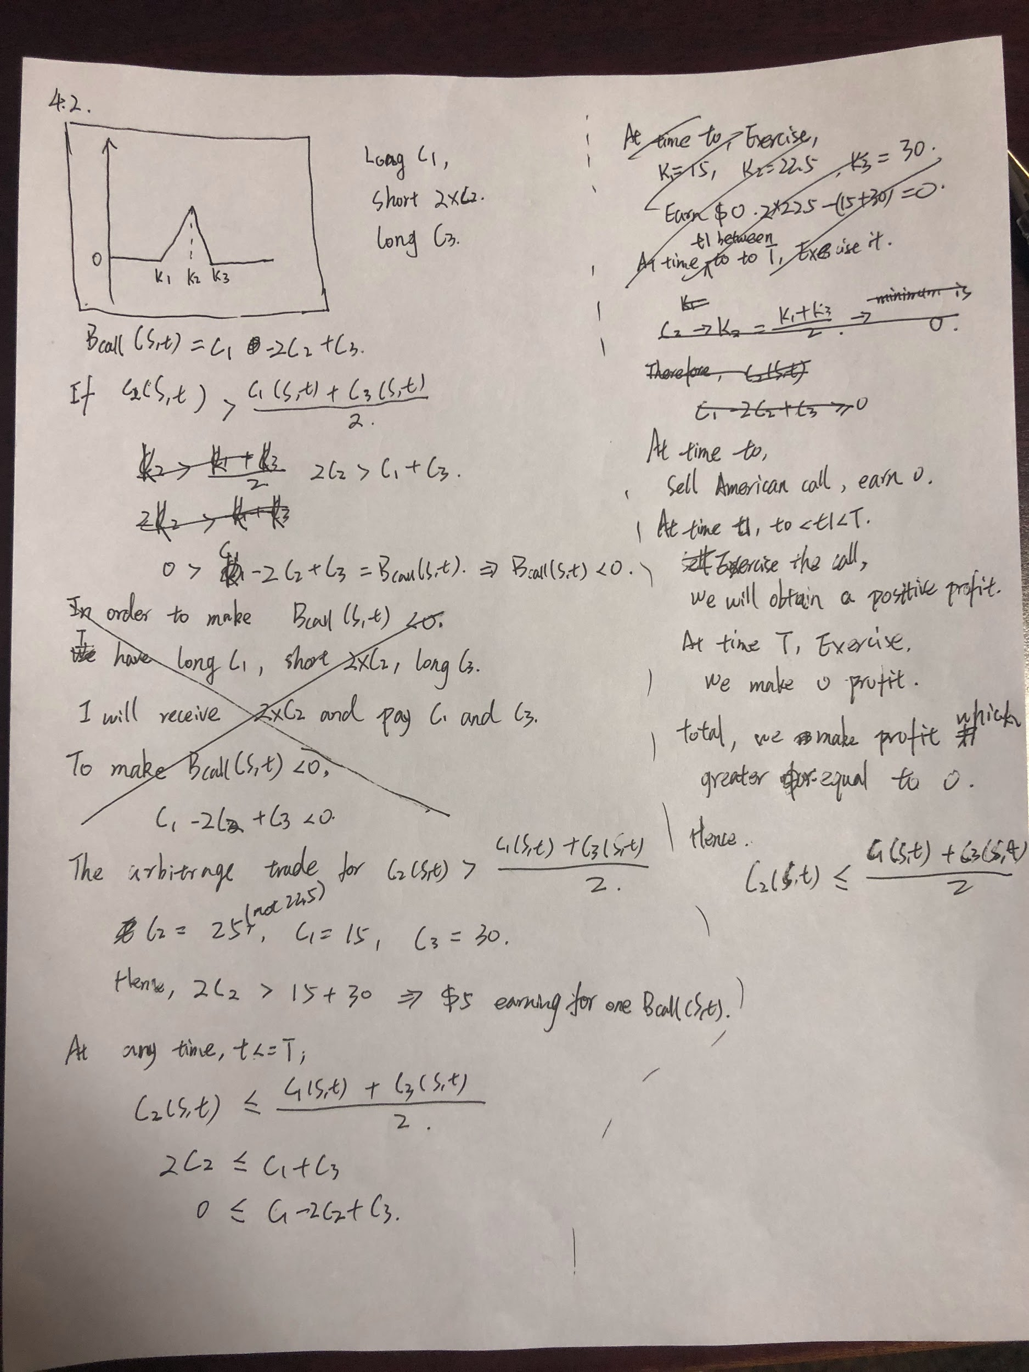

4.3

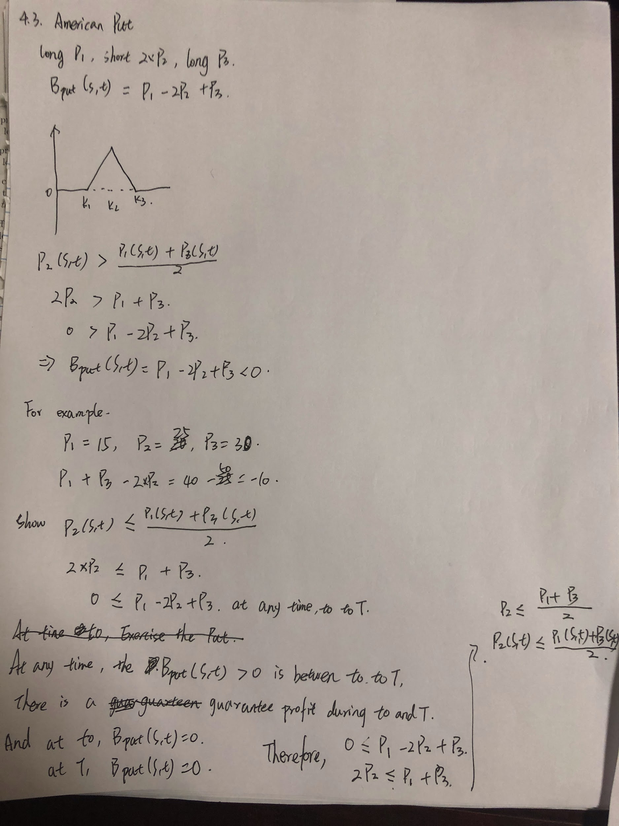

5. 2

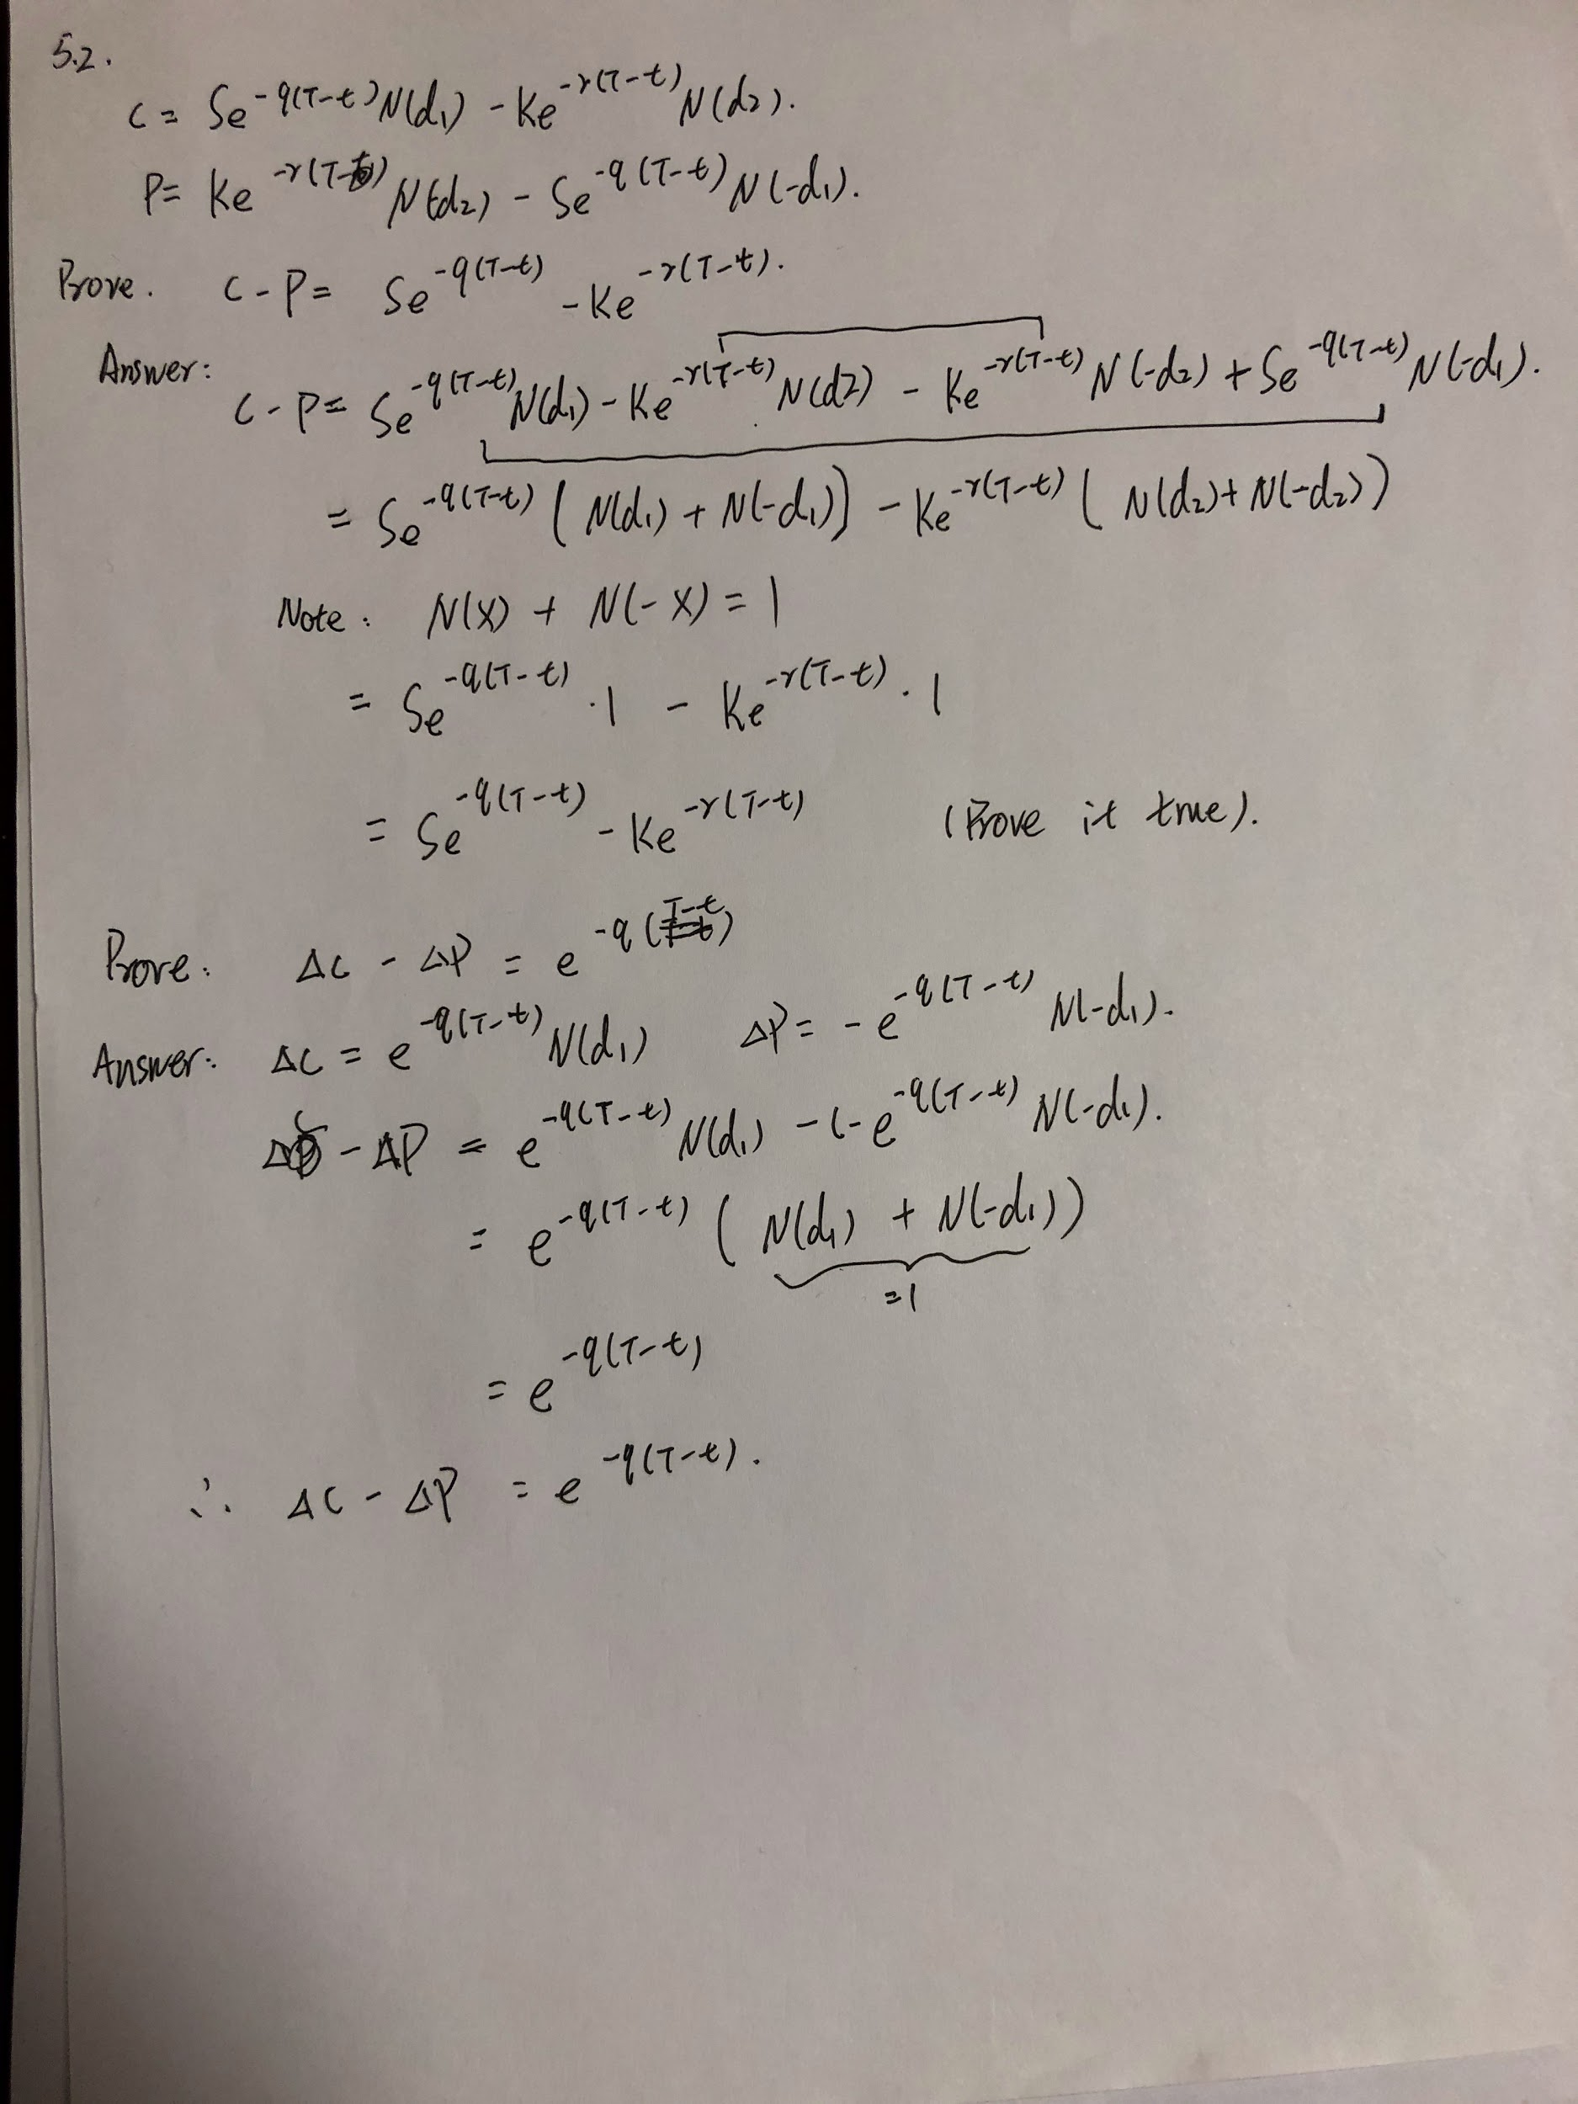

5.3

|  |  |
| --- | --- |
| K | X= 100 Bcall |
| 50 | **0.629216** |
| 75 | **0.990625** |
| 100 | **0.835512** |
| 125 | **0.552523** |
| 150 | **0.328343** |

Calculation done in code.

5.4

|  |  |
| --- | --- |
| Sigma | CBlack-scholes |
| 0.1 | **0.000371267** |
| 0.2 | **0.315483** |
| 0.3 | **1.9122** |
| 0.31 | **2.14078** |
| 0.4 | **4.59933** |
| 0.5 | **7.91229** |

Find sigma_0 that 1.99<c<2.01

|  |  |
| --- | --- |
| Sigma | CBlack-scholes |
| 0.3 | **1.9122** |
| 0.3035 | **1.99099** |
| 0.304 | **2.00236** |
| 0.3042 | **2.00691** |
| 0.3043 | **2.00919** |
| 0.305 | **2.02517** |
| 0.31 | **2.14078** |

Sigma_0 can choose between 0.3035 to 0.3043.

Let Sigma_0 =0.304, then, the delta = **0.145355 = 0.145**